Level 12 -> Level 13

The goal of this level is to read the content of **data.txt** file which is a hexdump of a file that has been repeatedly compressed and get the password.

Use cat data.txt command to view how the hexdump looks like.

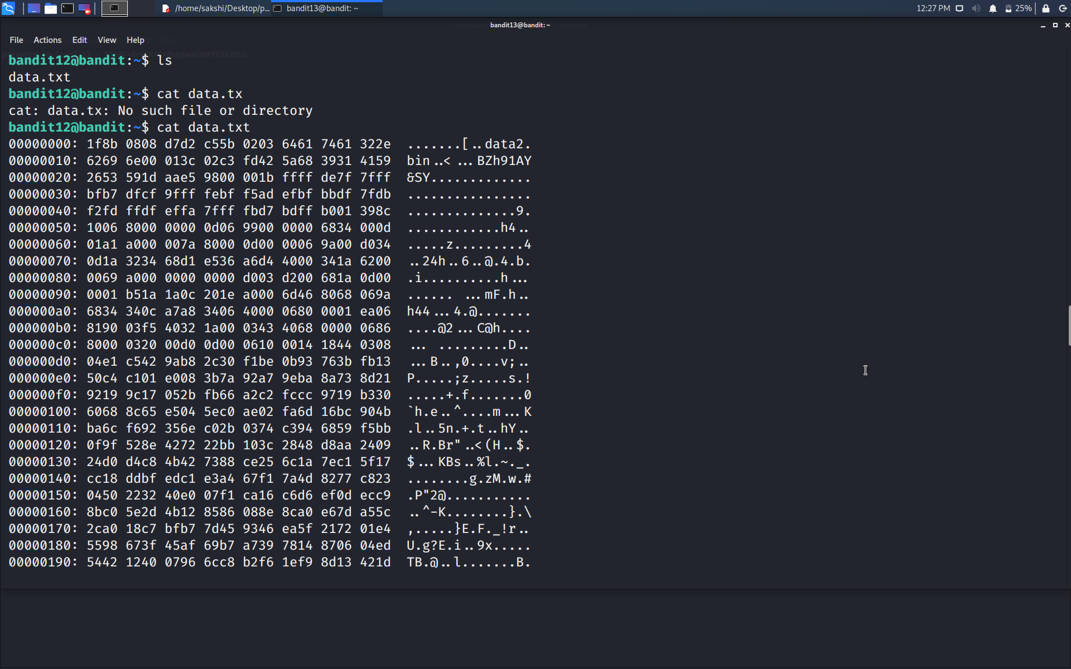

Step1 : Create a directory in /tmp directory and copy data.txt file into newly created directory.

Step2 : Firstly we need to reverse the hexdump. **xxd** creates a hex dump of a given file or standard input. It can also convert a hex dump back to its original binary form. **xxd** command with -r option performs reverse hexdump. So, here we will use command as: **cat data.txt | xxd -r > data. “> data”** is used to send the binary form of the file in the file named data.

Step3 : **File** command is used to check the type of file (i.e. data). It is a gzip compressed data file.

Gzip is a type of file format which is used by unix or linux systems to compress HTTP data before sending to the client. It can shrink the file upto 80% and improve the page load time and decreased bandwidth consumption. **.gz** – Indicates a file extension compressed by the gzip algorithm.

Step4 : So, now we will move the data of **data** file into the **data.gz** using **mv** command and using **gunzip data.gz** command we can decompress it.

Decompressed file will store as data file name with no extension. And again, using **file** command we will check the type of data file.

Step5 : Now we found that the file is bzip2 compressed file.

Bzip2 binds the files into a single file which takes less storage space as the original file use to take. It has a slower decompression time and higher memory use. It uses Burrows-Wheeler block sorting text compression algorithm, and [Huffman Coding](https://www.geeksforgeeks.org/tag/huffman-coding/). Each file is replaced by a compressed version of itself, with the name original name of the file followed by extension bz2.

Step6 : So, now we will move the data of **data** file into the **data.bz** using **mv** command and using **bzip2 -d data.bz** command we can decompress it.

Decompressed file will store as data file name with no extension. And again, using **file** command we will check the type of data file.

Step7 : This time the file type is **POSIX tar archive (GNU).** We can use the command **tar xvf data** to untar the file.

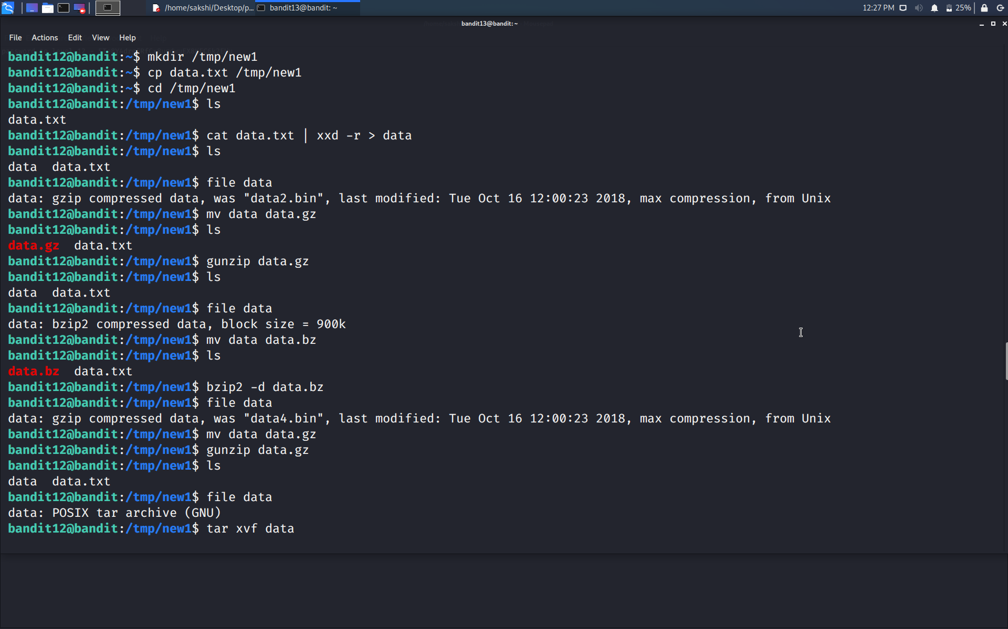

Step8 : Again using the file command we will check the type of file we are working on.

Step9 : Repeat the above steps utill we get the ASCII text file.

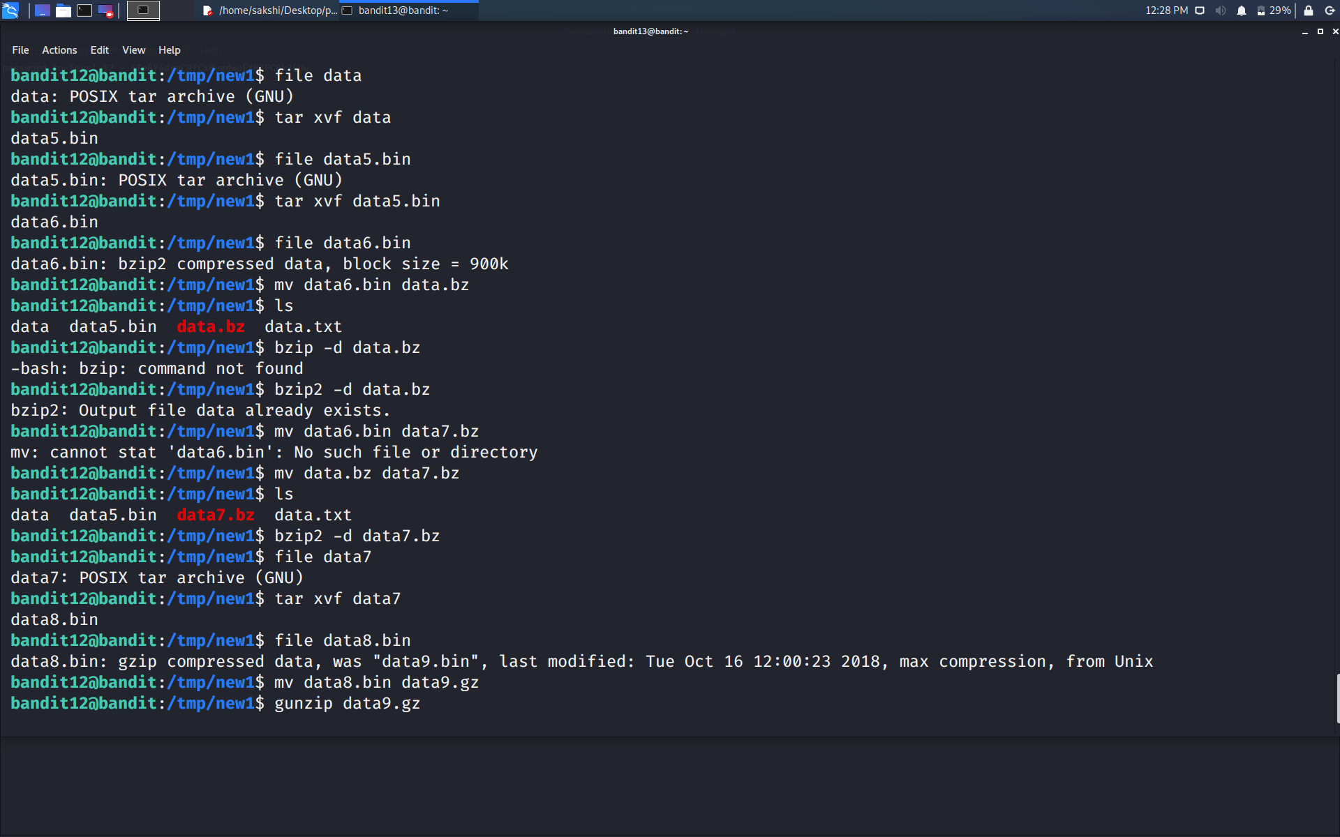

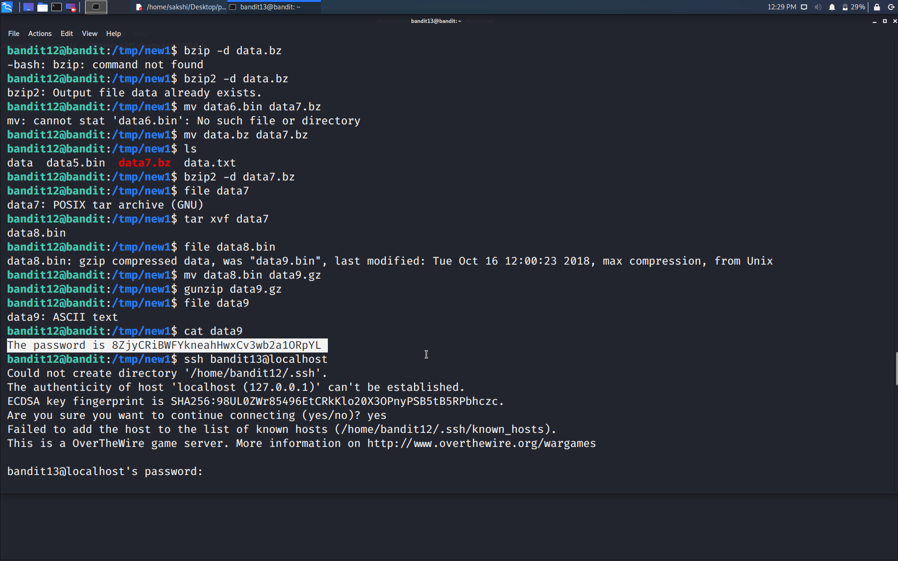

After repeatedly decompressing and checking the file type we finally got the ASCII text file whose content can be easily displayed using **cat** command.

Use command **cat data9 and get the password.**

Use the command **ssh bandit13@localhost** to connect to the level 13.

Enter the password and hit enter.

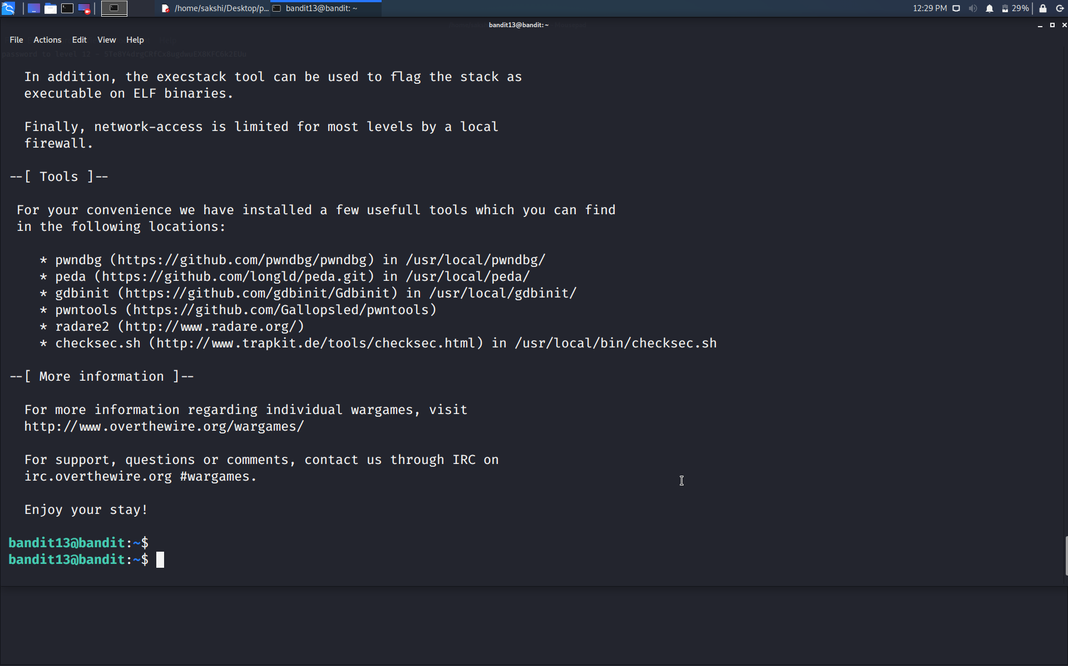

Successfully passed level 13.…